Week 9 – Technical Task
A – Getting an AWS Account & Accessing the AWS Management Console
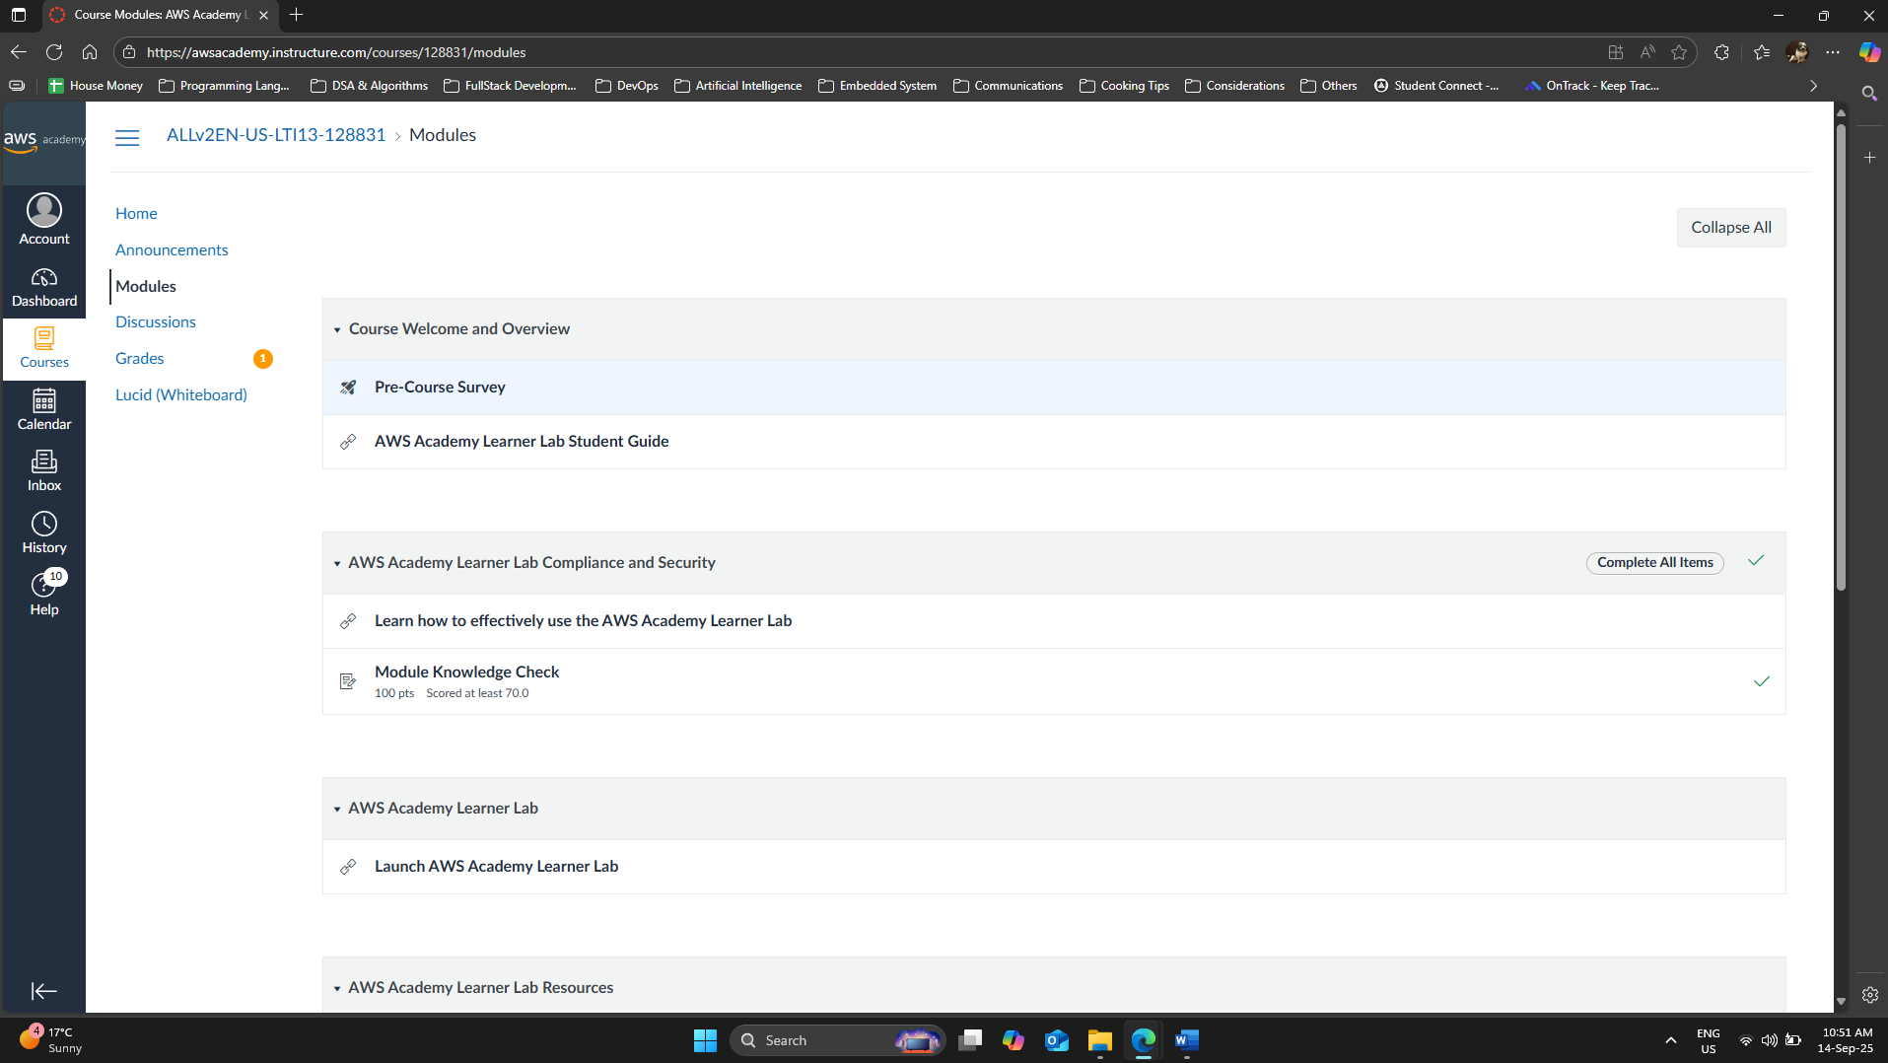
Picture 1 – Completed “Module Knowledge Check”.
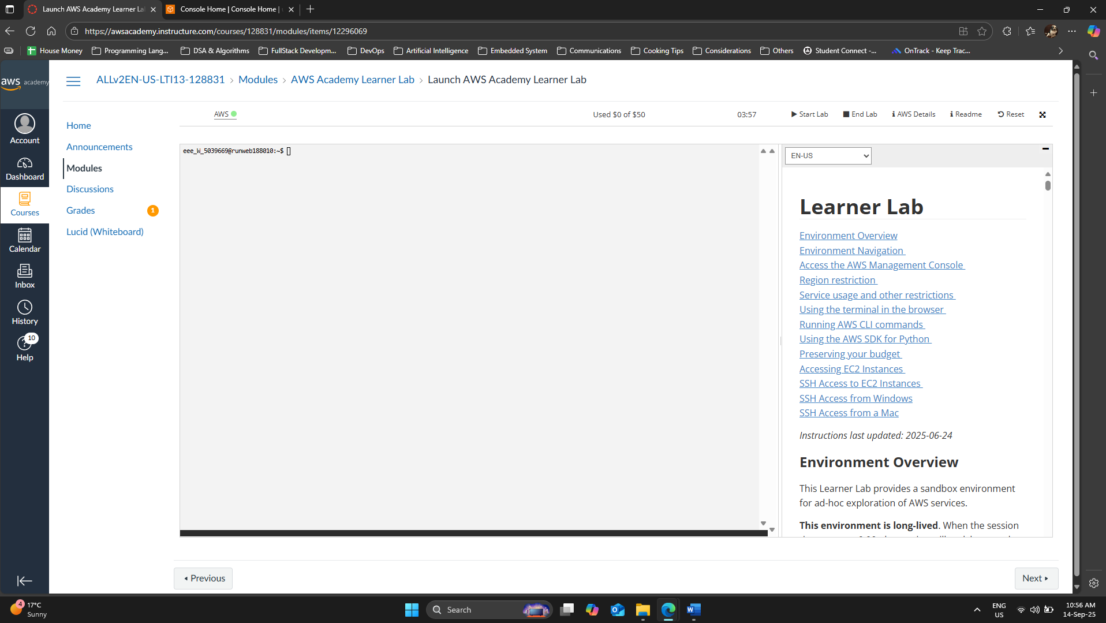
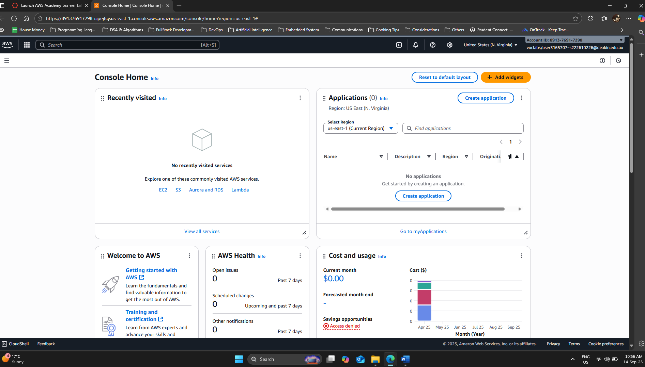

B – Using Ubuntu Linux VM in EC2
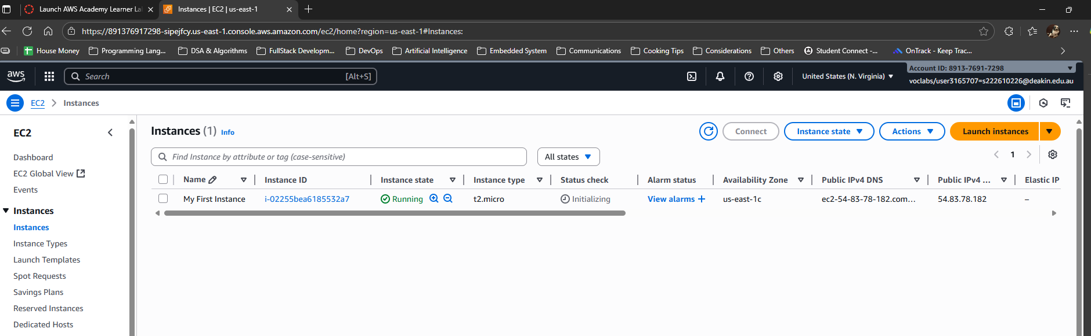
Picture 4 – Successfully created an EC2 called “My First Instance”.
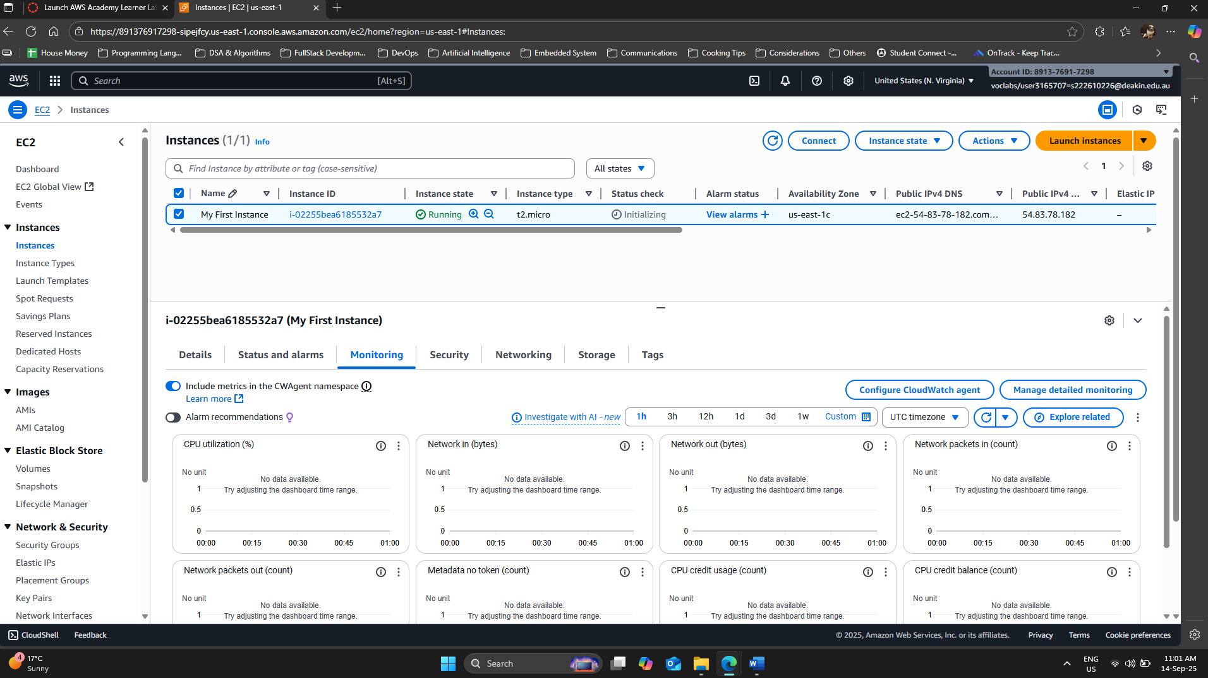
Picture 5 – Accessed “Monitoring” tab of the generated EC2 instance.
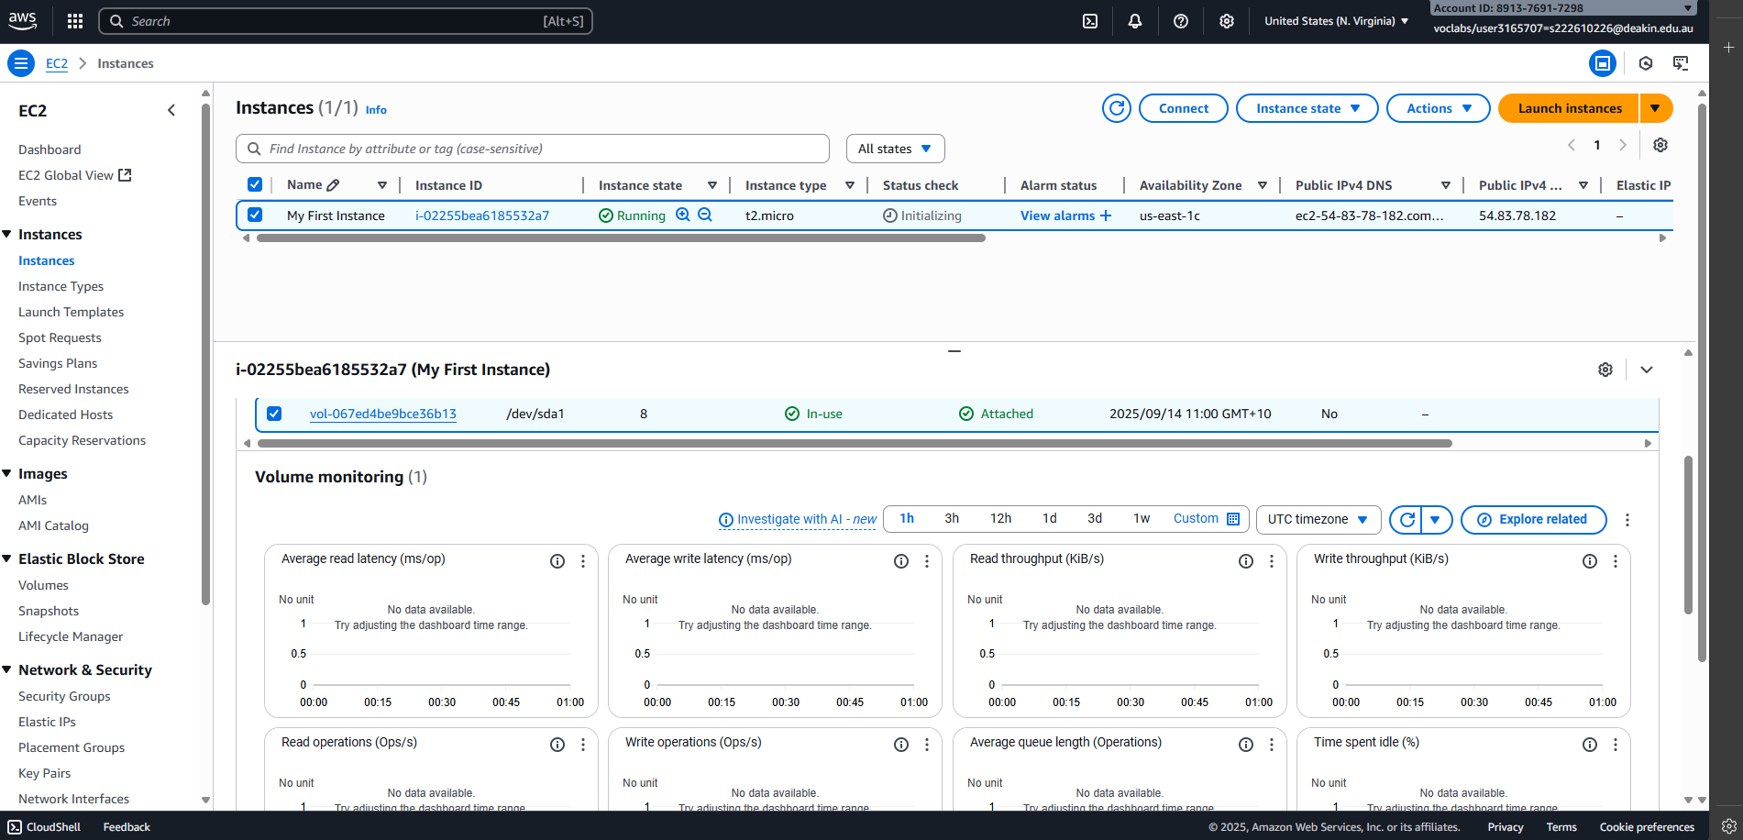
Picture 6 – Accessed “Volume” tab of the generated EC2 instance.
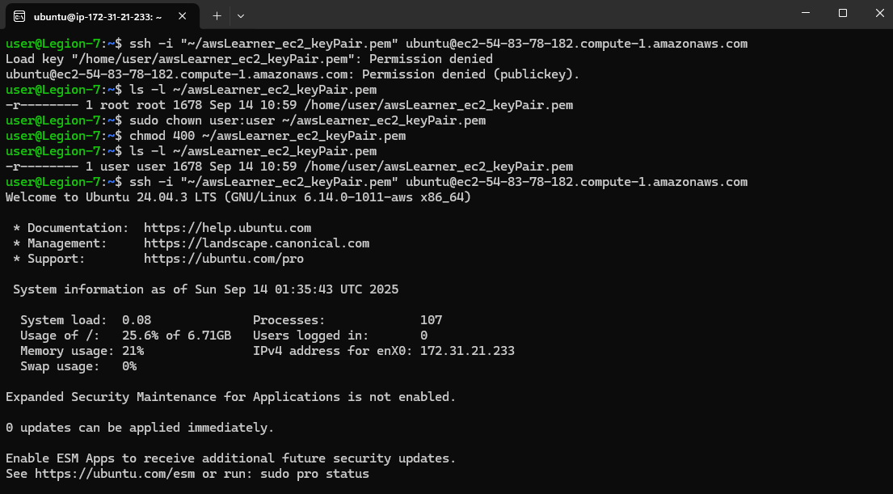
Picture 7 – Edited ownership to the generated keypair & successfully connected to the EC2 instance.

Method 1 - Installed wsl for window, then login to Ubuntu application. Copied the keypair from window – Download folder to \\wsl$ - \home\user. Then ran the code above (Picture 7) to configure the ownership to the copied keypair & connected it to EC2 “My First Instance”.

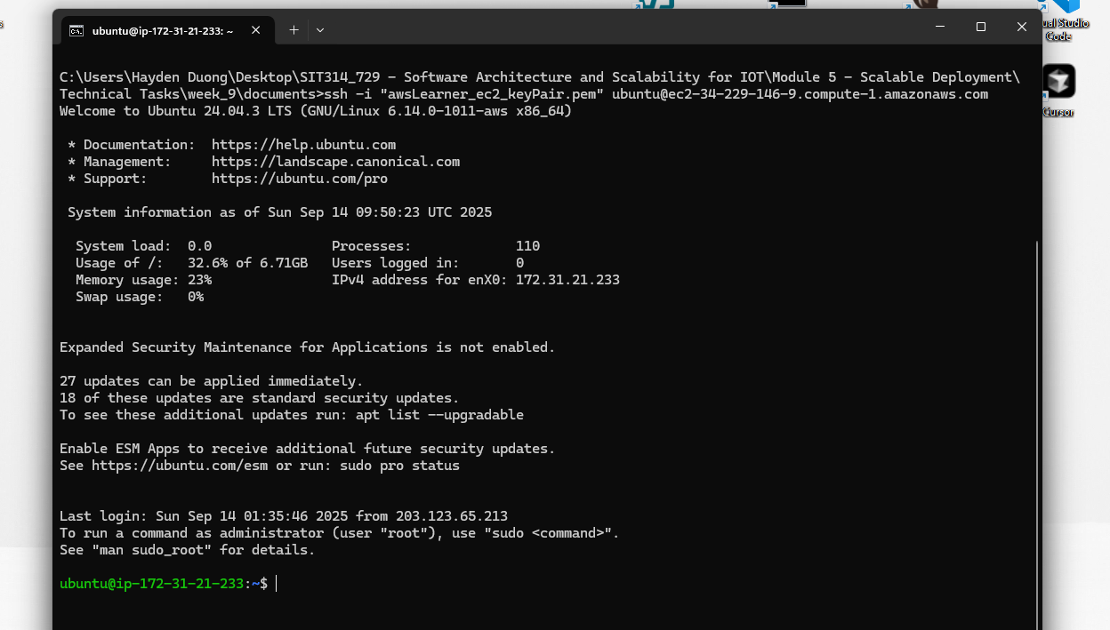
Picture 8 – Connected to EC2 via Windows 11 Command Prompt
Method 2 – Using Window Command Prompt (as OpenSSH is built-in to Windows 11): Locate the keypair file “.ssh” and changed it properties:
- Properties → Security → Advanced → Clicked “Disable inheritance” → Chose “Remove all inherited permissions from this object”.
- Click “Add” → “Select a principal” → Entered my username on my laptop & Clicked “Check Names” → Clicked “OK”. Then I made sure this user only has “Read” & “Read & execute” and “Apply” + “OK”.

C – Installing and configuring software on Linux
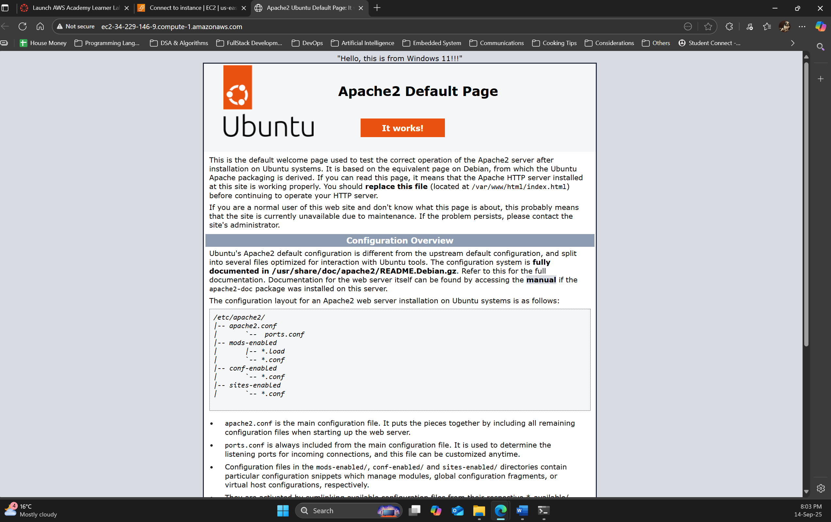
Picture 8 – Successfully displayed the message “Hello, this is from Windows 11!!!” on top on the Apache2 Default Page.
- I followed the lab instructions and modified the “index.html” found inside the Ubuntu OS.
- Accessed the Default Page through http://ec2-34-229-146-9.compute-1.amazonaws.com/
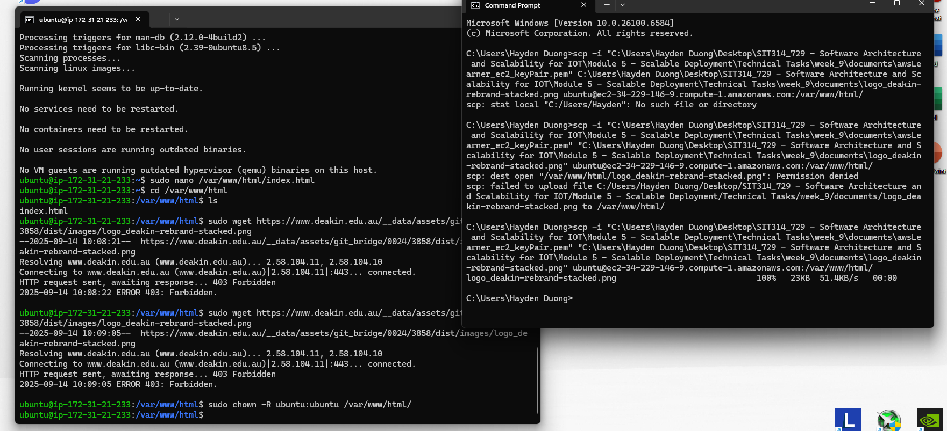
Picture 9 – Successfully “migrate” the manually downloaded .png from local Windows 11 to EC2 instance.
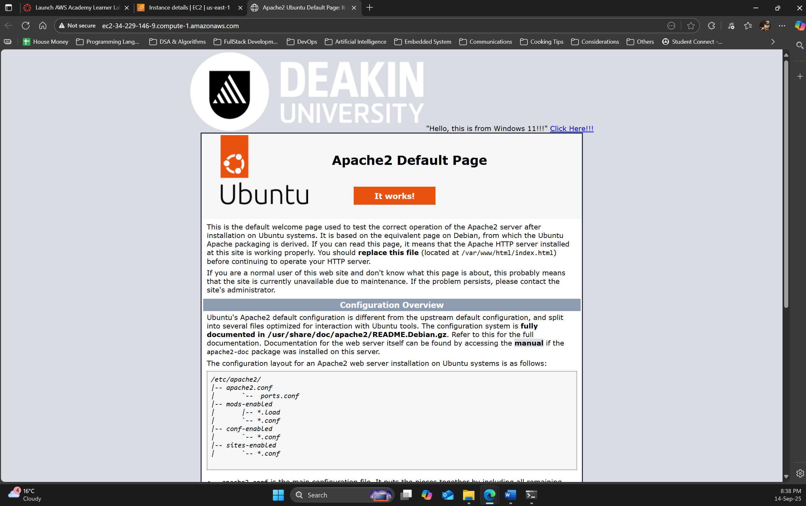
Picture 10 – Successfully displayed Deakin Logo & a link to Deakin University website.

D – Using Load Balancing in EC2
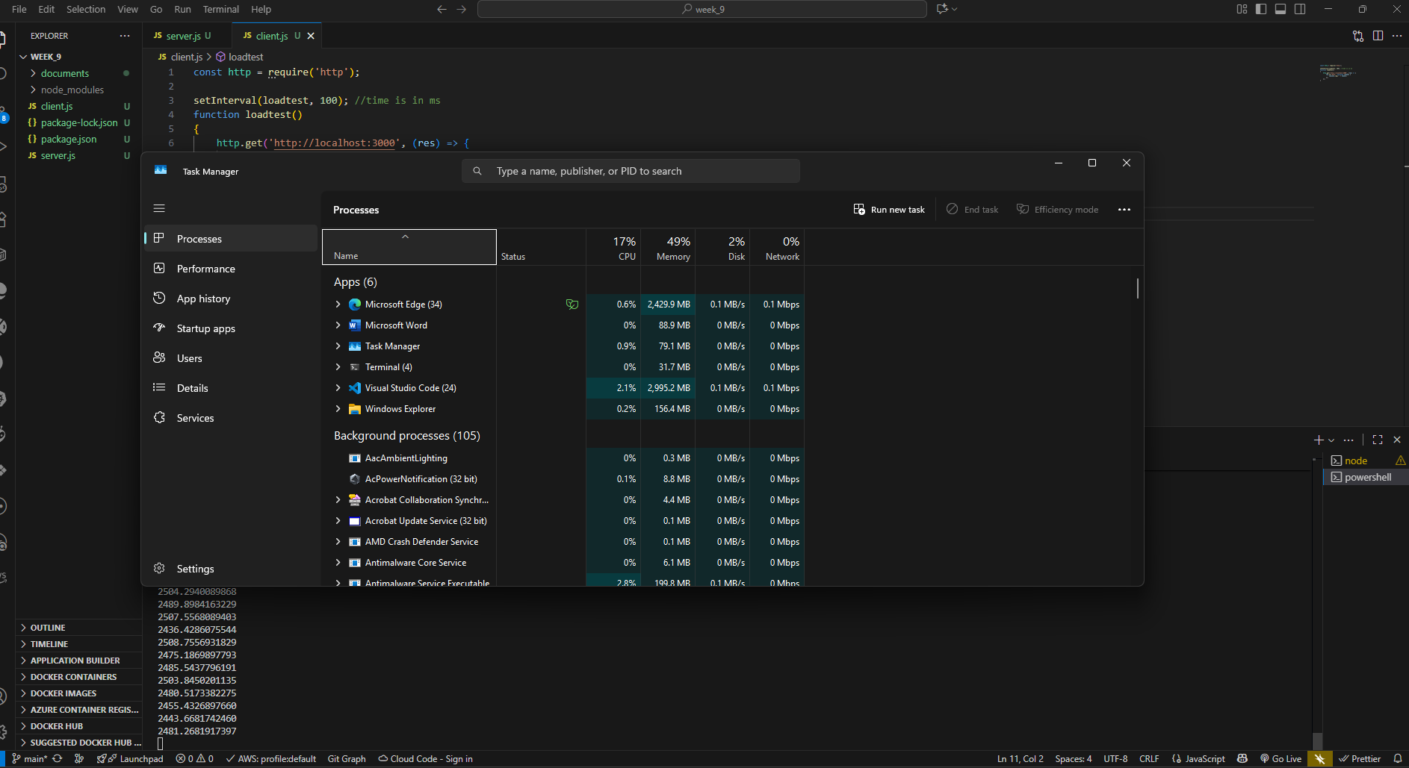Picture 10 – Windows 11 Task Manager shown high CPU usage of VScode (from running both node client.js & server.js)
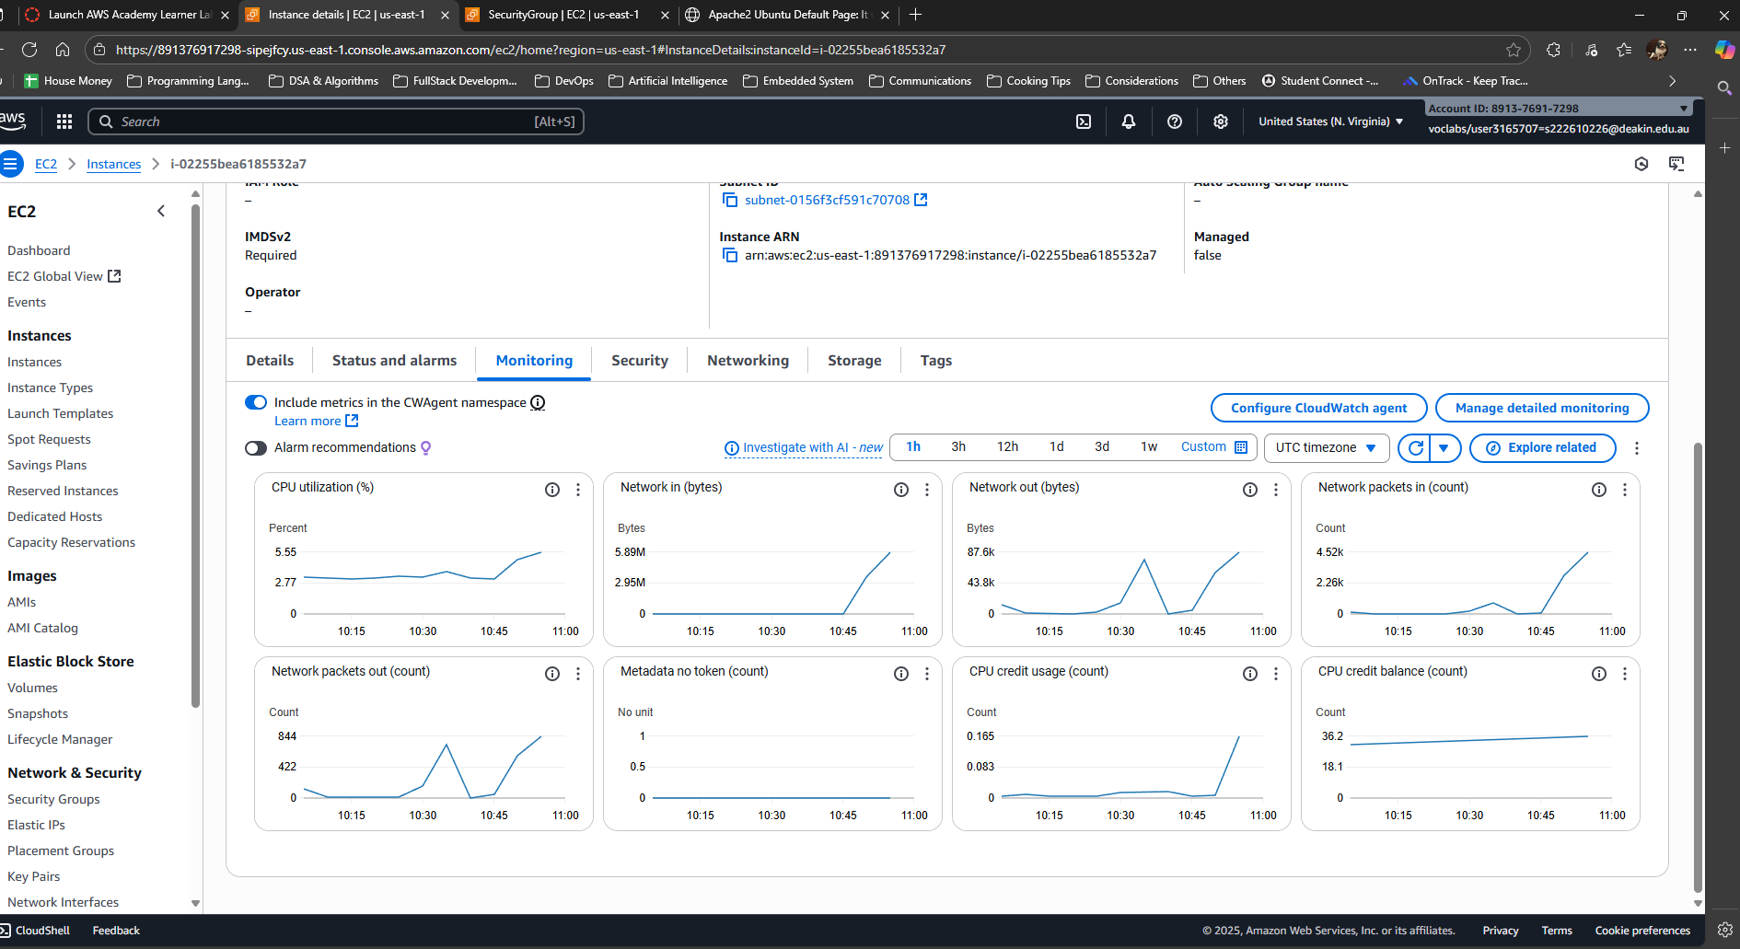
Picture 11 – CPU monitor results from running 3 client.js on local machine.
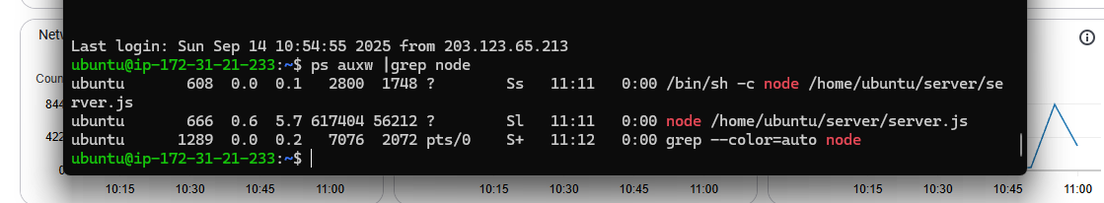
Picture 12 – Node instance is shown running as EC2 is rebooted after edited with crontab -e command.

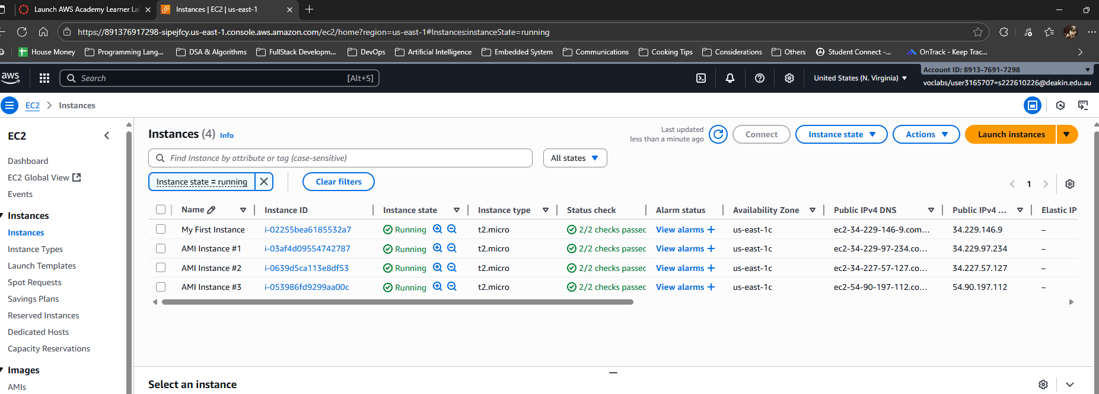
Picture 13 – Total 4 instances (1 original & 3 AMI-generated) are running.
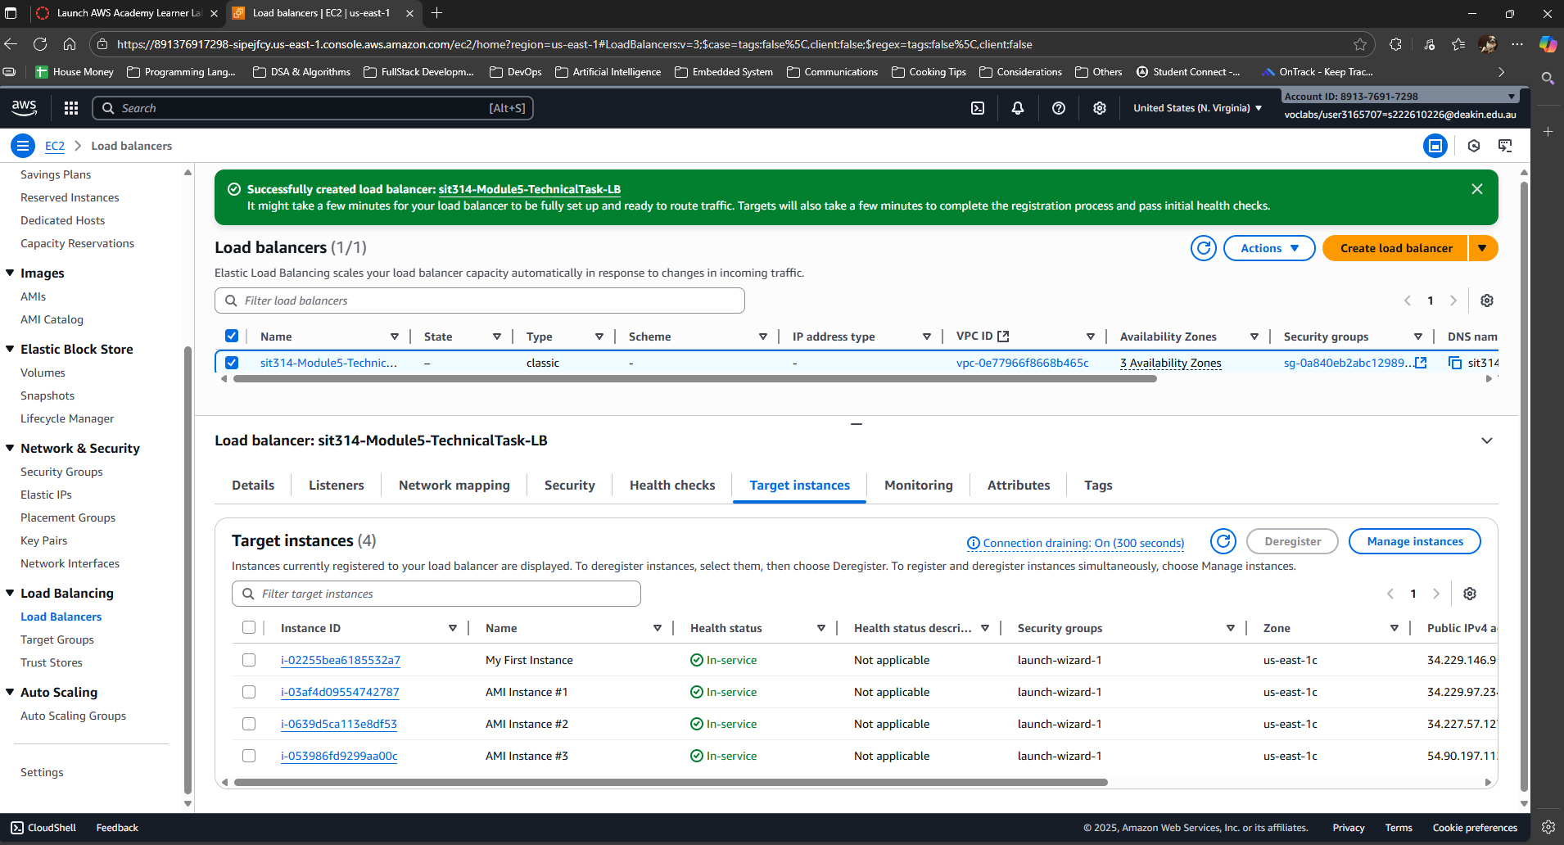
Picture 14 – Load Balancer - 4 target instances are running.
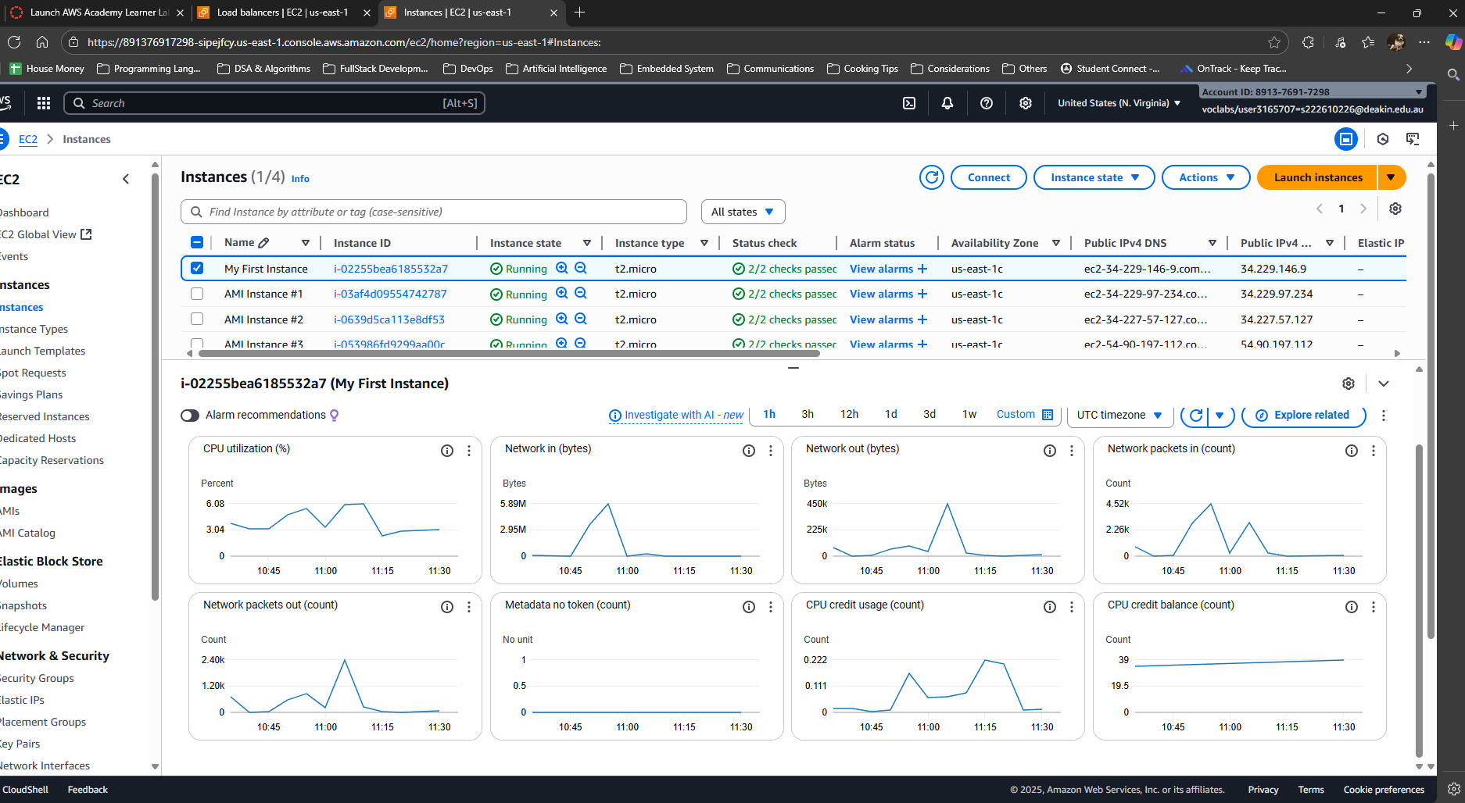
Picture 15 – Monitoring Result from “My First Instance”
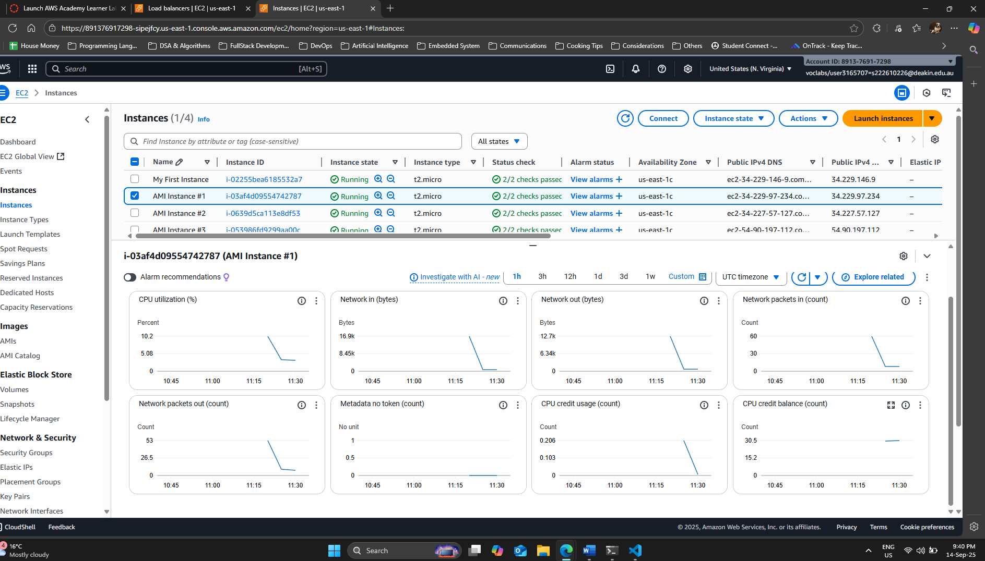
Picture 16 – Monitoring Result from "AMI Instance #1”
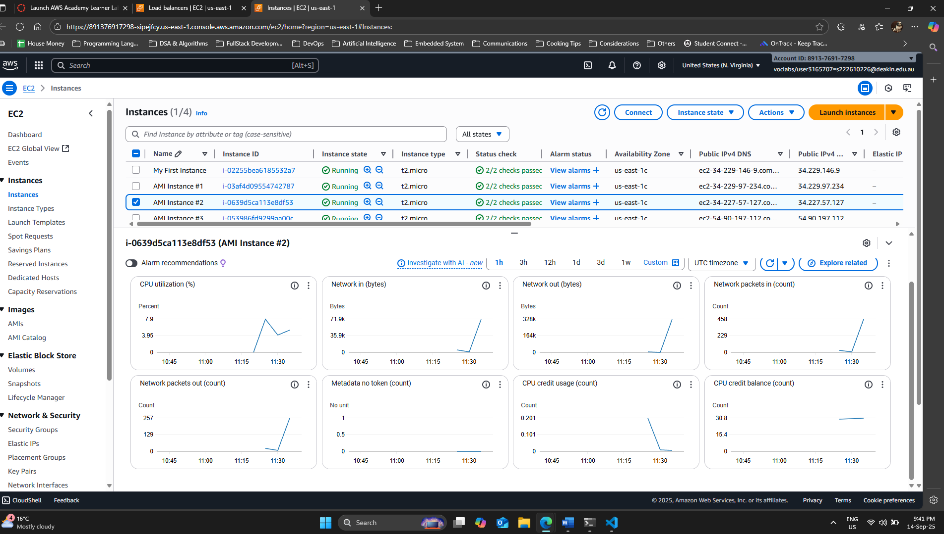
Picture 17 - Monitoring Result from "AMI Instance #2”
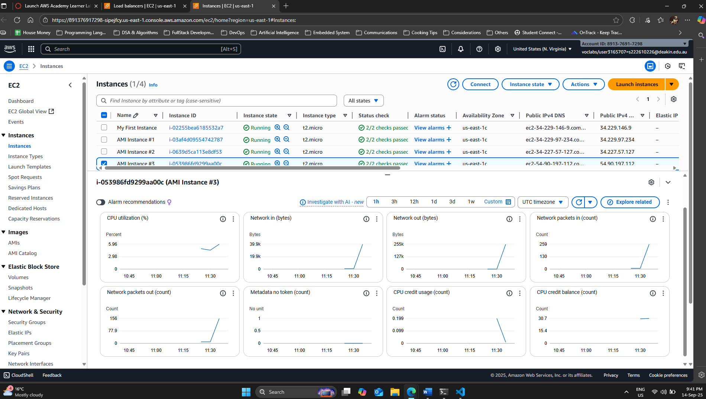
Picture 18 – Monitoring Result from “AMI Instance #3”
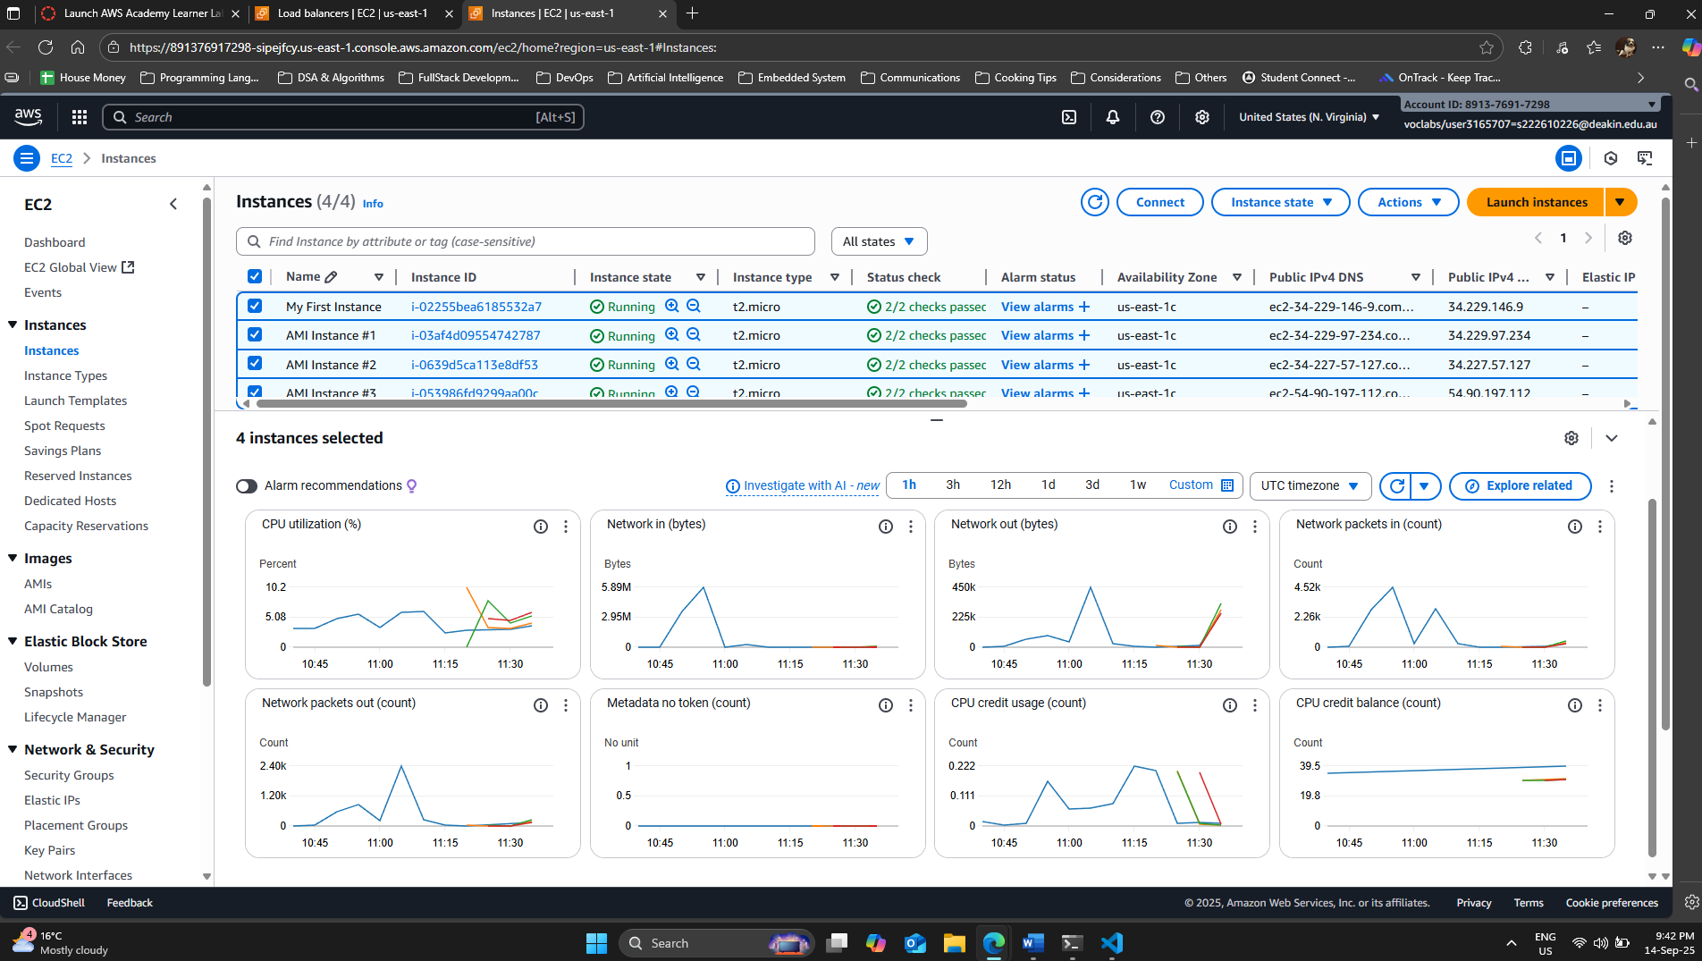
Picture 19 – Monitoring Result from all 4 running instances.
E – Clean Up
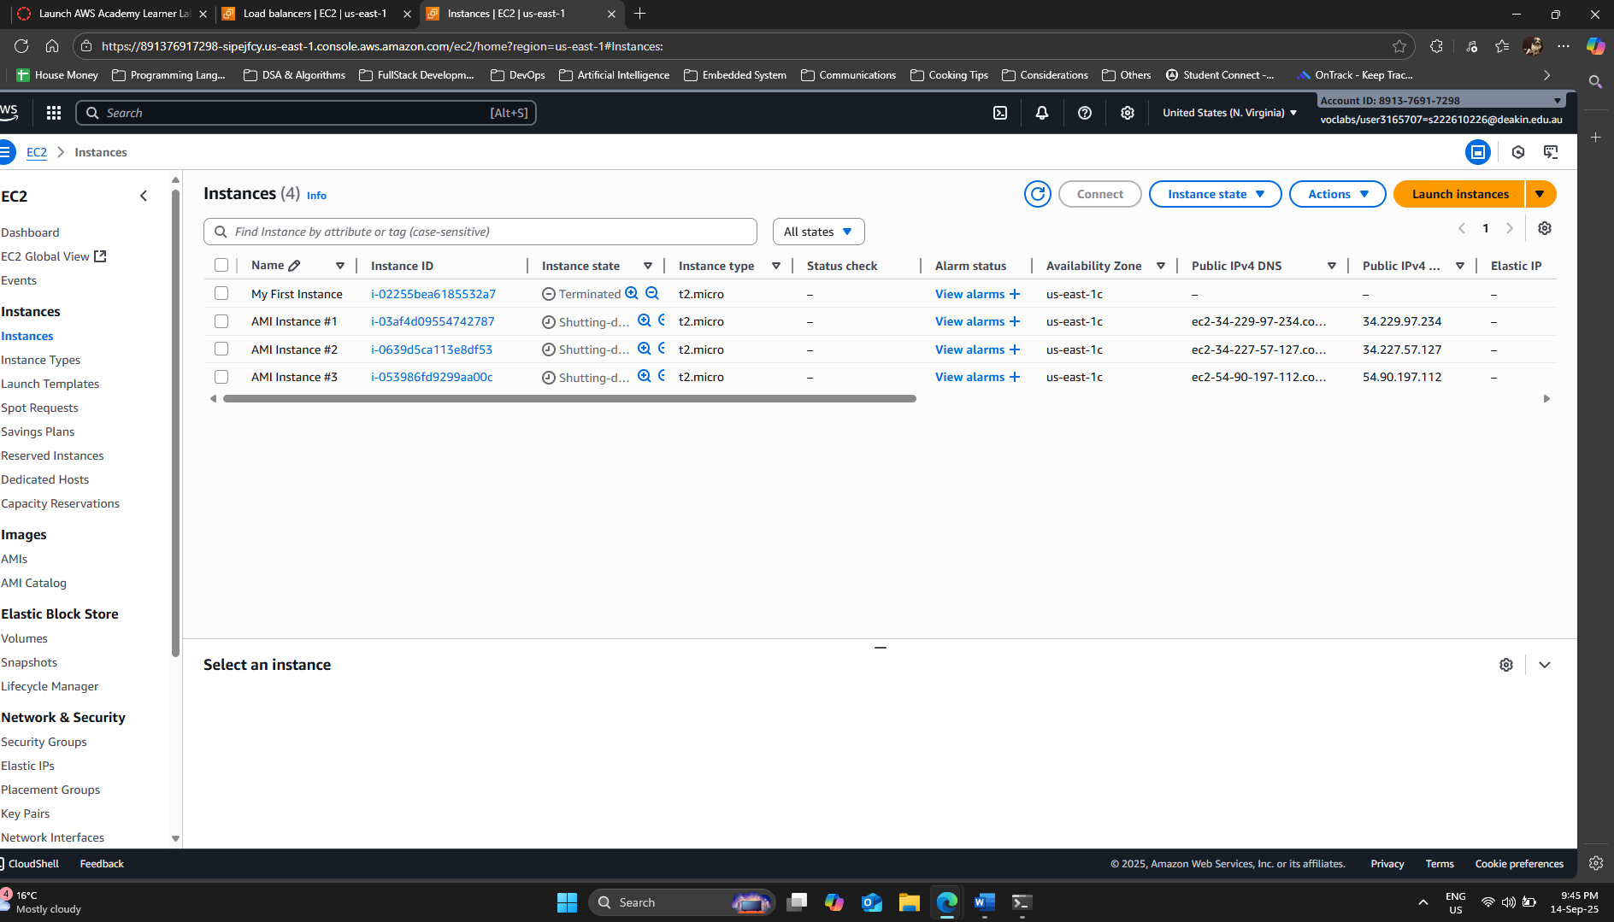
Picture 20 – Shutting Down and Terminating all 4 running instances.

